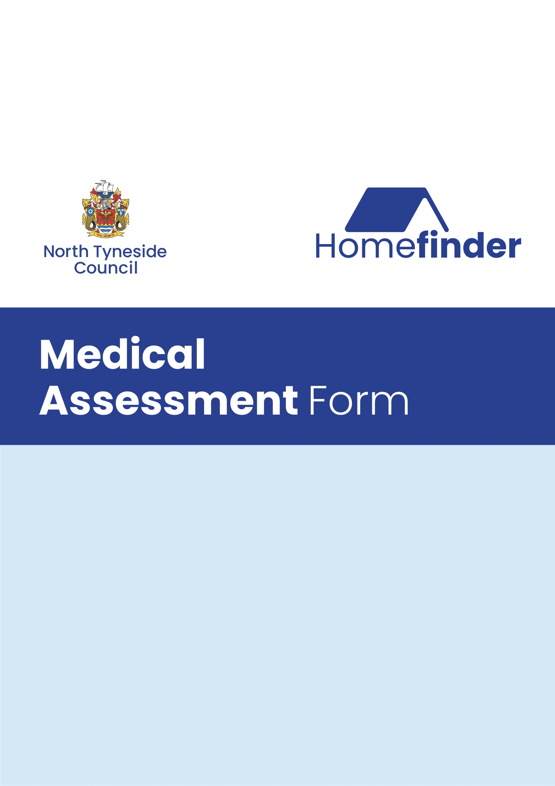
Application Reference:
Name:
Address:

This Medical assessment is designed to identify the housing needs of applicants who
are homeless or whose present accommodation is not helping their medical
condition or disability.

Please make sure you fill in all sections that apply to you. If you do not, the form will
be returned to you, as we will not be able to fully assess your case properly.

You must submit a patient summary form alongside this assessment. This can be obtained from your GP. Additional medical documentation eg consultant letters, health care professional assessments confirming your health situation may also be submitted.

You should only complete this form if:

- you want to be rehoused within North Tyneside (if you
wish to be consider for rehousing by another authority please contact the
relevant authority directly)

- Your disability or health problems are severe and permanent

- Your current home makes your disability or health problems worse; or

- Your current home is difficult to manage due to your disability or health.

Difficulties arising from overcrowding affect a number of households in North
Tyneside and additional medical priority will generally not be awarded for problems
solely relating to overcrowded accommodation.

You must fill in a separate form for each member of the household who has difficulty
managing in the home due to their disability or health problems.

Please do not fill in this form if your disability, health or housing problems are one or more of the following:

- You are pregnant or have a problem with your current pregnancy that is likely
to improve once you have had the baby.

- You have an illness or injury that is likely to get better with treatment, for
example if you are recovering from surgery.

- Your housing problems are solely due to the state of disrepair in your home
for example damp, condensation; lift breakdown, pest or rodent infestation.
Contact your landlord and discuss how to resolve these issues.

- Your housing problems are because of anti-social behaviour or neighbour
problems. Contact your Landlord or your local authority environmental health
department and discuss how to resolve these issues.
Health Questionnaire

1. About you (the applicant):

Title: Mr Mrs Miss Ms Other (please state): Date of Birth:

Surname: First name:

Address:

Postcode:

Telephone (Home): (Work):

Mobile: E-mail:

2. About the person with the health problems

Title: Mr Mrs Miss Ms Other (please state): Date of Birth:

Surname: First name:

Telephone:

Mobile: E-mail:

Please state your relationship to the main applicant:

3. Tell us about your disability or health problems

Please state what your disability or health problems are  Including your medical diagnosis if you know it.  (please use a separate sheet if necessary) | How long have you had this condition?

Your doctor’s details

Doctor’s name
Address
Telephone

Please give details of any prescribed medication you are currently taking for
your condition and how often you take this:
(Please use a separate sheet for additional information)

Dosage | Type of Medication

Are you awaiting any treatment, or surgery to treat your condition, e.g a hip
replacement?

Yes □ No □

If “yes” please give us details and the date:
Your Mental Health

Do you have a diagnosed mental illness?

Yes □ No □

Please tell us about how your current accommodation affects your health?

Do you receive help from Social Services, Community Mental Health Team or any
other agencies?

Yes □ No □

If yes, who helps you and what type of help do they provide?
Please give name and contact details.

Learning Disability

Do you have a diagnosed learning disability?

Yes □ No □

Please give details:

If you do not have a physical health problem or disability, please go to section 5

4. About your ability to get around and do things:

Do you use any mobility aids to help you get around?
Please tick the box(es) that apply.

Walking Aid | Yes | No | Sometimes
Stick
Frame
Crutches
Attendant propelled wheelchair |  |  |  | Indoors | Outdoors
Self-propelled wheelchair
Powered wheelchair

Are the mobility aids prescribed or self-purchased?

Have you fallen or had a history of falls in your current home?

Yes □ No □

If you answered yes, please provide more details of frequency, location and cause
and provide details of any injuries sustained:

Do you have difficulty climbing stairs: Yes □ No □

If yes please explain why:

Do you have a history of seizures or blackouts?
Yes □ No □

If yes, please give details of the cause, location and frequency and the approximate date of the last episode:

5. About where you currently live:

What type of property do you live in?

Bed-sit □ Maisonette □ Bungalow □ House □ Hostel □ Other □

Ground floor flat □ Upper floor flat □

Who lives in the property?

Name: Date of Birth: Gender:

Relationship to person with health problems:

Medical assessment form (Y/N)

How many bedrooms do you have?

How many bedrooms does your household need?

Why do you need this number of bedrooms?

Are you currently: (tick box)
Council Tenant |  | Housing Association tenant
Private Tenant |  | Owner occupier
Homeless |  | Living with friends or family

If you do not have a physical health problem or disability, please go to section 6.

Access to property

Is there lift access to your property

Yes □ No □

Please state the number of steps you need to climb to get to your front door:

How many steps do you need to climb inside your home:

Access to bathing and toileting facilities

How many toilets do you have in your home?

On what floor of your home is your toilet/s? Ground floor □ Upper floor □

On what floor of your home is your bathing facilities?
Ground floor □ Upper floor □

Are you able to access bathing facilities?
Please tick all that apply

Unable |  | With help
Independently |  | With difficulty
With Equipment

Do you have any equipment or adaptation in your home that you use to help you
because of your health / disability?

Please give details:

Would you consider remaining at your property if equipment / adaptations could be provided to address your difficulties?

Please advise us how your current accommodation is affecting your health, also give us any information you consider useful when assessing your application to be rehoused (if necessary, please continue on a separate sheet of paper).

Please tell us what type of accommodation and facilities you feel would meet your health needs (if necessary, please continue on a separate sheet of paper)

6. Support

Existing support network

Name and Contact Details
Family Member
Social worker/care manager
Occupational Therapist
Community Psychiatrist Nurse
Macmillan Nurse
Health Visitor
Physiotherapist
Consultant / specialist
Other e.g. support worker

We may need to get more information from your GP or other health professionals.
Please complete sign and date the authorisation from.

7. AUTHORISATION FOR MEDICAL INFORMATION

I confirm the information I have given on this form about my circumstances or the
person I am filling the form in on behalf of is true.

I understand that you may cancel my priority that has been awarded to my housing application if you find I have given information that is false or misleading.

I will inform North Tyneside Homefinder if there is a change in my medical
circumstances which could affect my housing needs.

Where necessary, I give permission for the Housing Mental Health Practitioner to access my secondary mental health records and provide recommendations in relation to my re-housing.

I give permission for North Tyneside Homes and its medical advisor to obtain further information from my GP and / or any other health professional mentioned on my medical assessment form.

Signed:

PRINT:

Date:

Signed Parent / Guardian :

NB: Parent/Guardian must sign for persons under the age of 18 years

**Please ensure that you provide proof of medical conditions to accompany this form. This could be a patient summary form which
can be obtained from your GP.**

Please email your competed form to homefinder@northtyneside.gov.uk or alternatively you can post this to:

Homefinder
Housing & Property Services
Block A, The Killingworth Site, Station Road, Killingworth, NE12 6QQ

